Brief
Stage 1 has 3 battles - birthday party ecstasy, void deck glue sniffing

Glue Sniffing Incident with l
So game starts out with a cutscene or whatever about Bob’s life in the RPG map. He can walk around free or whatsoever. For sub areas like houses or HDB void decks, there is a subtly glowing arrow under the HDB to hint that there is an entrance there, like Pokemon.

Again, there is an glowing spot in the void deck to hint that there is a “quest” nearby. As the character approaches a specific distance near the “quest”, a monologue pops out like “!!! That’s Antonio and Axel! And Dash the cool dude! What are they doing!” He auAntonioatically walks forward and a dialogue begins with Dash persuading him using peer pressure or he’ll call him a sissy. Antonio and Axel is too busy sniffing and addicted. Bob is worried(could use a cut scene to imagine how life would be like to Bob if he refuses to join in the “fun” - bullied in school by this trio). He is caught in a dilemma.

eee-u eee-u eee-u eee-u(erm this is the sound that plays in pokemon when the player encounters a wild pokemon and screen fades) the simulation battle in the brain starts.

If he wins,

If not, cutscene showing him sniffing glue and hints that its a bad idea. After cutscene, Bob ends up with a headache

Drug Used: Heavy Duty Glue
Background: Cheap, can be bought from any hardware shop.
Real Adverse Effects: Headache, cardiac arrests, brain damage
How it is represented: Walk in opposite directions
SIDE NOTE for a preview for how hallucination can be portrayed in the game, search for a video gameplay/walkthrough of Far Cry 3 “Kick the Hornet’s Nest” and observe how the player’s vision and aiming is disrupted from smoking the weed (as he burns the fields)
→ Map background constantly fading/changing to something else, disrupted movement
(save hallucination for sabutex or ice)

DIALOGUE

Monologue before entering “quest”

“Bad day...”

Monologue upon sighting trio:

Big “!”
“Woah, its those three popular guys Dash, Antonio and Axel! Hmm... what are they doing?”

*automatically speedwalks towards them after reaching a certain distance from the trio*

Dialogue before quest starts:

Dash: “Hey [nickname of Cody], whataya doing here?”
Cody: “Nothing much, just making my way home from a boring day of school”
Antonio: “Boring? Wanna know how to make it better? Check out this scent bro...” *holds up can* “Y’know what this smell is?” *sniffs*
Cody: “What?”
Axel: “Its the smell of HAPPINESS! Wanna try?”
Cody: “!!! That’s heavy duty glue!”
Dash: TRY IT. DON’T BE A SISSY. COME ON DUDE, MAN UP.
Cody: But its...they’re...they’re drugs!!!!!! Aren’t we suppose to say NO to them?”
Dash: Go be a sissy then. Sissy.

Monologue for Cutscene(maybe):

Life’s gonna be such a torment! Oh no, I’ll be…
called a sissy…
ignored in school…
or even…
get beaten up for being a sissy! AH!
WHAT SHOULD I DO!
*eee-u eee-u eee-u eee-u whirlpools into simulation screen*
During Simulation
We need to show submission in more bad, show resistance in more good
More BAD: Glue sounds cool….
More GOOD: Yes! That’s right! I can’t take drugs! NEVER!

If he wins,
Life Does Not Rewind my friends. You gotta stop!
If he loses,
AHHH! Why does my head hurt so much?
Screen Elements:
Health Bar
There is a meter
Dialogue Box/Dialogues Popping out
Stage 1 Layout
HDB
levels
entrance→ x
*some distance*
(character starts here)

Simulation layout
Dialogue Box
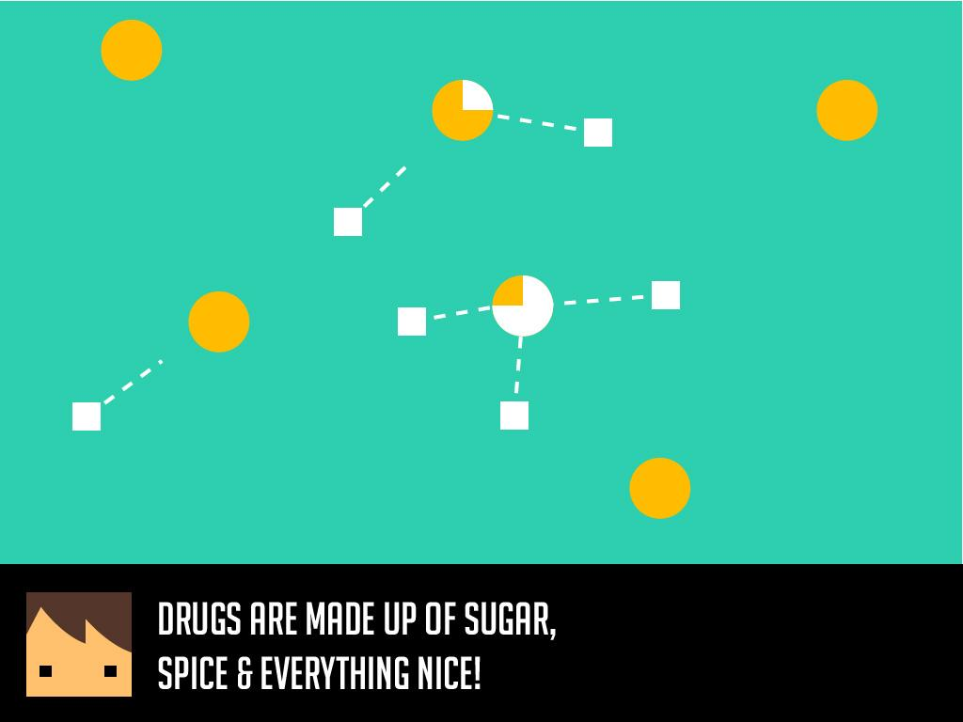

Orange Circles: Good neurons
White Squares: Bad neurons
Dotted Lines: Forming links

Specifications
Battle box
- Dialogue box - 24:5 (HEIGHT)Screen Ratio
- Map area -
- Scroll buffer -
- Scroll magnitude -
RPG Map
- Dialogue box - appears on “quest”
  - 24:5 Screen Ratio
- Play map ON screen
  - distance per “stroll”: ____ which is
- Play map OFF screen

DIMENSION REFERENCE FOR “MIND PLAY”

